**Lesson 4 Demo 11**

**Understanding Static Pods**



Steps to be followed:

1. Creating Static Pod in worker node

**Step 1: Creating a static pod in a worker node**

| **Note:** Choose worker1 node to deploy the pod. |
| --- |

1. Navigate to /etc/kubernetes/manifests/ folder:

***cd /etc/kubernetes/manifests***



1. Create a yaml file to create a static pod:

***sudo vi staticpod.yam***l



1. Add the following code to the **staticpod.yaml** file:

***apiVersion: v1***

***kind: Pod***

***metadata:***

***name: static-web***

***labels:***

***role: myrole***

***spec:***

***containers:***

***- name: web***

***image: nginx***

***ports:***

***- name: web***

***containerPort: 80***

***protocol: TCP***

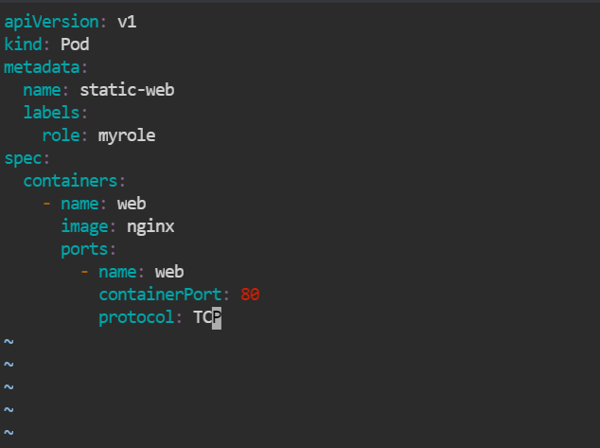

1. Use the following command to modify the kubelet config file:

***sudo vi /var/lib/kubelet/config.yaml***



1. Modify the ***staticPodPath*** in ***/var/lib/kubelet/config.yaml*** file:

**staticPodPath: */etc/kubernetes/manifests/staticpod.yaml***

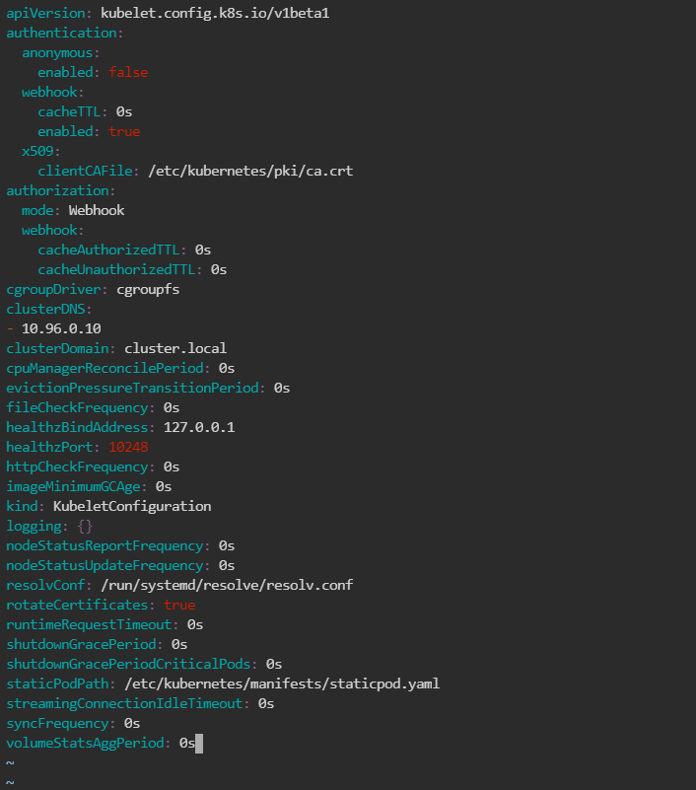

1. Run the following the command to restart the kubelet service:

***sudo systemctl restart kubelet***



1. Check in Master by typing:

***kubectl get pods -A***

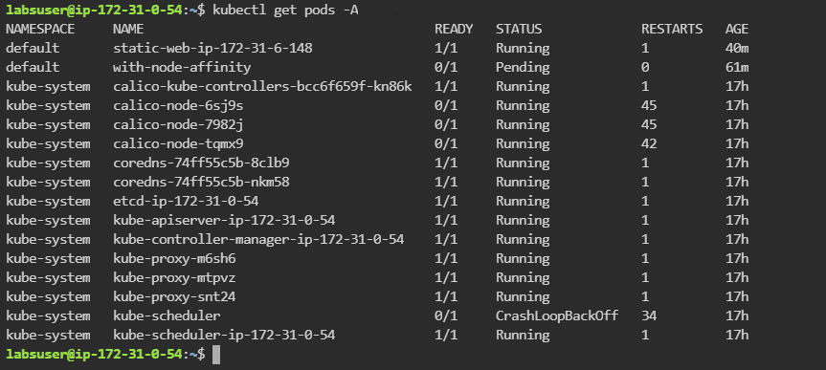

1. Check whether the container runs in docker by running the following command in **worker1** node:

***docker ps***

